**PEARSON HND**

**IN COMPUTING (LEVEL 4)**

**PROGRAMMING**

**MOHAMMED MOHAMME ISLAM**

**DR. SAMAA MUKHAIMAR**

**ALDAR ACADEMY**

GARHOUD

056 22 373 56, mohammedmohammedislam12@gmail.com



Table of Contents

**Introduction** 3

**Definition of an Algorithm** 3

**What is An Algorithm** 3

**ALGORITHM FEATURES :** 4

**Algorithm Features** 4

**Algorithm vs. Program** 5

**Computer Program:** 5

**Characteristics of a Computer Program** 6

**Flowchart Symbols** 7

**Key Functions of Symbols** 8

**Key Takeaways:** 9

**Types of Algorithms** 10

**1. Sorting Algorithms:** 10

**2. Searching Algorithms:** 10

**Sorting Algorithms** 12

**1. Selection Sort:** 12

**2. Bubble Sort:** 13

**Algorithm of Selection Sort** 15

**Selection Sort method** 17

**Algorithm of Bubble Sort** 17

**Bubble Sort method** 19

**Searching Algorithms** 20

**Linear Search method** 22

**Main mathod** 22

**Execution** 23

**How Computers Understand Programming** 23

**Programming Paradigms** 26

**Procedural Programming** 26

**Object-Oriented Programming (OOP)** 26

**Event-Driven Programming:** 27

**Relationship Between Procedural, Object-Oriented, and Event-Driven Programming** 27

**Relationship between Procedural and Object-Oriented Programming:** 28

**Relationship between Event-Driven and Object-Oriented Programming:** 28

**Software Development Life Cycle (SDLC): Guiding the Software Building Process** 29

**What is SDLC?** 29

**SDLC Phases or Stages:** 29

**1. EmployeeManagementSystem Class:** 31

**2. MainMenu Class:** 32

**3. Add_Employee Class:** 33

**4. Employee_Detail Class:** 34

**5. Update_Employee Class:** 35

**6. Show_Employee Class:** 36

**7. Remove_Employee Class:** 36

**8. CodeExit Class:** 37

**9. file.txt:** 37

**SDLC Models:** 44

**Integrated Development Environment (IDE): Streamlining Software Development** 46

**What is an IDE:** 46

**Why is an IDE Important?** 46

**Debugging** 48

**What is the Debugging Process:** 48

**Launching and Debugging a Java Program:** 48

**Coding Standards and Best Practices** 50

**Key Components of Coding Standards:** 52

**Introduction**

**Definition of an Algorithm**

At its essence, an algorithm is a set of step-by-step instructions designed to perform a specific task or solve a particular problem. In the realm of computing, algorithms act as the guiding principles that enable computers to process information, make decisions, and execute tasks efficiently.[1]

**What is An Algorithm**

An algorithm is a step-by-step procedure or set of instructions designed to perform a specific task or solve a particular problem. In the context of computing, an algorithm serves as a blueprint for a computer program, outlining the logical sequence of operations needed to achieve a desired outcome.

Algorithms play a fundamental role in the field of computer science, guiding the computer's actions and decisions. They serve as the foundation for the development of software and applications, dictating how data is processed, manipulated, and presented to users.

At its core, an algorithm is a series of well-defined steps that, when executed in a particular order, lead to a specific result. These steps are crafted with precision to address a problem or perform a function, making algorithms an integral part of various computational tasks.

The importance of algorithms extends beyond the realm of programming. They are pervasive in our daily lives, influencing the technology we interact with regularly. From search engine algorithms determining relevant search results to sorting algorithms organizing data, these sequences of instructions impact the efficiency and functionality of the digital world.

an algorithm is a set of instructions that guides a computer in performing tasks or solving problems, forming the backbone of computational processes and technological advancements.

**ALGORITHM FEATURES :**

**Algorithm Features**

Algorithms, the backbone of computational processes, are characterized by distinct features that contribute to their efficacy and reliability. Understanding these features is crucial for crafting algorithms that are not only efficient but also accessible to both humans and machines.[2]

**Clear and Unambiguous:** Algorithms demand clarity in their instructions, leaving no room for ambiguity or misinterpretation. A clear algorithm is one that is easily understood by developers and computers alike. This feature ensures that the intended actions and outcomes are apparent, minimizing the risk of errors in execution.[2]

**Well-Defined Inputs:** The behavior of an algorithm should be deterministic, meaning the same set of inputs will consistently produce the same output. Well-defined inputs contribute to the reliability and predictability of the algorithm, establishing a stable foundation for its execution.[2]

**Well-Defined Outputs:** Similar to well-defined inputs, the algorithm must explicitly outline the expected outputs. This feature ensures that the results produced by the algorithm are precisely specified, leaving no room for ambiguity or uncertainty. Well-defined outputs are essential for evaluating the success and accuracy of the algorithm.[2]

**Finiteness:** An algorithm must exhibit finiteness, indicating that it will always terminate after a finite number of steps. This feature ensures that the algorithm does not enter an infinite loop or an indeterminate state, providing a clear endpoint to its execution. Finiteness is a key characteristic that distinguishes a well-designed algorithm from a potentially problematic one.[2]

**Effectiveness:** All operations to be performed must be sufficiently basic, allowing them to be done exactly and in finite length. Effectiveness emphasizes the practicality of the algorithm. Operations within the algorithm should be well-defined, basic, and achievable within finite time, contributing to the overall efficiency and reliability of the algorithm.[2]

**Independence:** Instructions can be implemented in any language and produce the same results.Independence ensures that the algorithm's logic is language-agnostic. The instructions can be translated into any programming language without altering the desired outcome, enhancing the algorithm's versatility and applicability.[2]

**Feasible:** The feasibility of an algorithm is paramount for its practical execution with the available resources. It should be straightforward, generalizable, and workable within the constraints of existing technologies. Importantly, an algorithm should not incorporate elements or technologies from the future, ensuring its applicability and executable nature in the present.[2]

the features of a well-crafted algorithm extend beyond mere functionality. Clarity, determinism, precision, finiteness, and feasibility collectively contribute to the effectiveness and practicality of an algorithm, making it a valuable tool in the world of computing and problem-solving.[2]

**Algorithm vs. Program**

In the realm of computing, algorithms and programs are fundamental concepts, each serving distinct roles in the process of solving problems and executing tasks.[3]

**Computer Program:**

A computer program is a set of instructions written in a programming language. It serves as the concrete implementation of an algorithm. Programs are composed using the syntax and structure dictated by a programming language, translating high-level algorithmic logic into machine-readable code.[3]

**Characteristics of a Computer Program**

**Written in a Programming Language:** Programs are expressed in languages such as Python, Java, or C++, each with its syntax and rules[3]

.

**Implements an Algorithm:** The program embodies the logic and steps of an algorithm, translating the abstract into executable code.[3]

**Characteristics of an Algorithm**

**Written in Natural Language:** Algorithms are often described in human-readable terms, making them accessible for conceptual understanding.[3]

**Solves a Problem:** The primary purpose of an algorithm is to solve a problem or accomplish a specific task.[3]

**Distinguishing Features**

**1. Abstraction Level:**

**Program:** Operates at a lower level, involving detailed syntax and specific language conventions.

**Algorithm:** Operates at a higher, more abstract level, focusing on conceptual steps rather than language-specific details.[3]

**2. Representation:**

**Program:** Represents a concrete, executable set of instructions in a programming language.

**Algorithm:** Represents a conceptual solution in natural language, lacking the specific syntax required for execution.[3]

**3. Execution:**

**Program:** Meant to be executed by a computer, providing a tangible solution to a problem.

**Algorithm:** Serves as a blueprint for problem-solving, requiring translation into a program for practical implementation.[3]

a computer program is the tangible, executable form of an algorithm, written in a programming language. An algorithm, expressed in natural language, is the conceptual framework outlining the logical steps for problem-solving. While programs are specific and executable, algorithms provide a higher-level, abstract understanding of the problem-solving process.[3]

**Flowchart Symbols**

Flowcharts serve as visual representations of processes, and various symbols are employed to convey specific elements within these diagrams. Each symbol holds a distinct meaning, aiding in the clear communication of the flow and logic of a process.[4]

**1. Start/End:**

**Symbol:** Oval or Terminator

**Description:** Signifies the beginning or end of a process. Often used to indicate the starting and concluding points of a flowchart.[4]

**2. Arrows:**

**Symbol:** Arrow

**Description:** Connects different elements in the flowchart, illustrating the sequence and direction of the process. The arrow indicates the order in which the steps occur.[4]

**3. Input/Output:**

**Symbol:** Parallelogram

**Description:** Represents the input or output of data. This symbol is employed when the process involves taking in external data or generating output as a result of the process.[4]

**4. Process:**

**Symbol:** Rectangle

**Description:** Denotes a specific task or operation within the process. This symbol encapsulates the actions or steps that occur as part of the overall process.[4]

**5. Decision:**

**Symbol:** Diamond

**Description:** Represents a decision point in the process where a question is posed, and the flow diverges based on the answer. The diamond typically contains a yes/no question or conditions that determine the flow direction.[4]

**Key Functions of Symbols**

**Clarity in Representation:** Each symbol serves a unique purpose, contributing to the clarity and understanding of the flowchart. The use of standardized symbols enhances communication and comprehension.[4]

**Sequential Direction:** Arrows connect the symbols, guiding the reader through the sequence of events. The direction of the arrows indicates the order in which the steps or processes occur.[4]

**Logical Decision Points:** The diamond symbolizes decision points, prompting a choice or condition that influences the flow of the process. This allows for the representation of alternative paths based on specific criteria.[4]

**Input and Output Identification:** The parallelogram symbol clearly identifies points in the process where external data is input or where the process produces output. This aids in recognizing the interaction between the process and its external environment.[4]

the symbology of flowcharts, including start/end ovals, arrows, parallelograms, rectangles, and diamonds, creates a visual language for representing processes. Understanding these symbols facilitates the creation and interpretation of flowcharts, fostering effective communication of complex processes.[4]

**Key Takeaways:**

**Precision in Communication:** Clear input-output relationships and unambiguous instructions contribute to the precision of the algorithm, ensuring that its purpose and results are clearly communicated.[4]

**Practicality and Finiteness:** The requirement for basic, achievable operations and a finite endpoint emphasizes the practicality and reliability of the algorithm, aligning it with real-world constraints.[4]

The independence characteristic enhances the algorithm's adaptability, allowing it to be seamlessly implemented across different programming languages while maintaining consistent results.[4]

these characteristics collectively shape algorithms into powerful tools for problem-solving, providing a structured and reliable framework for computational processes.

**Types of Algorithms**

Algorithms, the driving force behind computational processes, come in various types, each tailored to specific tasks and problem-solving scenarios. Here are three fundamental types of algorithms, each serving a distinct purpose:[5]

**1. Sorting Algorithms:**

**Definition:** Sorting algorithms are sets of instructions designed to take an array or list as input and arrange the items into a particular order.

**Significance:** Sorting algorithms play a crucial role in organizing data. They reorder elements based on specific criteria, facilitating efficient search operations and enhancing the overall accessibility and utility of the data.[5]

**2. Searching Algorithms:**

**Definition:** Searching algorithms are designed to check for the existence of an element or retrieve an element from any data structure where it is stored.

**Significance:** Searching algorithms are essential for locating specific information within a dataset. They systematically examine the data to determine whether a particular element is present and, if so, retrieve its location or associated information.[5]

**Definition:** Graph algorithms constitute a set of instructions that traverse or visit nodes of a graph.

**Significance:** Graph algorithms are pivotal in understanding and navigating interconnected data structures. They explore relationships between nodes in a graph, uncovering patterns, identifying optimal paths, and solving problems related to network connectivity and dependencies.[5]

**Key Functions of Each Type:**

**Sorting Algorithms:**

Organizing Information: Arrange data in a specific order, facilitating efficient retrieval and analysis.

Enhancing Accessibility: Improve the accessibility and readability of data, particularly in scenarios involving large datasets.[5]

**Searching Algorithms:**

Information Retrieval: Locate specific elements within a dataset quickly and accurately.

Decision-Making: Enable decision-making processes based on the presence or absence of specific data points.[5]

**Graph Algorithms:**

Exploration and Analysis: Traverse nodes and edges of a graph, uncovering patterns and relationships.

Problem Solving: Solve complex problems related to network connectivity, pathfinding, and dependency analysis.[5]

**Real-World Applications**

**Sorting Algorithms:**

E-commerce: Facilitate the sorting of products based on various criteria for a seamless shopping experience.

Database Management: Optimize data retrieval by organizing it efficiently using sorting algorithms.[5]

**Searching Algorithms:**

Web Search Engines: Power the search functionality by quickly identifying and retrieving relevant web pages.

Data Retrieval Systems: Enable efficient data retrieval from databases and storage systems.[5]

**Graph Algorithms:**

Social Networks: Uncover patterns of connections between individuals in social networks.

Transportation Systems: Optimize routes and connectivity in transportation networks for efficient travel.[5]

sorting, searching, and graph algorithms represent foundational tools in the world of computing, each contributing uniquely to the efficient processing and analysis of data and relationships. Understanding these types of algorithms is essential for developers and computer scientists working on diverse problem-solving tasks.[5]

**Sorting Algorithms**

Sorting algorithms are crucial tools in computer science, facilitating the organization of data for efficient retrieval and analysis. Here, we delve into two distinct sorting algorithms, each employing a unique approach to arrange elements:[5]

**1. Selection Sort:**

**Description:** Selection Sort is an effective and efficient sorting algorithm based on comparison operations. It operates by adding one element in each iteration. The key concept is to select the smallest element in the array and move it to the beginning by swapping it with the front element.[5]

**Methodology:**

In each iteration, identify the smallest element in the unsorted portion of the array.

Swap this smallest element with the first element in the unsorted portion.

Gradually, the sorted portion grows from the front of the array.[5]

**Significance:** Selection Sort is straightforward and easy to implement, making it suitable for small datasets where simplicity is preferred.[5]

**2. Bubble Sort:**

**Description:** Bubble Sort is the simplest sorting algorithm, working by repeatedly swapping adjacent elements if they are in the wrong order. This algorithm is not recommended for large datasets due to its high average and worst-case time complexity.[5]

**Methodology:**

Compare each pair of adjacent elements in the array.

If they are in the wrong order, swap them.

Repeat these steps until the entire array is sorted.[5]

**Significance:** Despite its simplicity, Bubble Sort is not the most efficient algorithm for large datasets. Its usefulness lies in educational contexts and situations where a simple sorting method is sufficient.[5]

**Comparative Analysis:**

**Selection Sort:**

**Advantages:**

* Effective for small datasets.
* Simple and easy to understand.

**Limitations:**

* Inefficient for large datasets.
* Time complexity can be high, especially for extensive arrays.

**Bubble Sort:**

**Advantages:**

* Simple and easy to implement.
* Requires minimal auxiliary space.

**Limitations:**

* Inefficient for large datasets.
* Higher time complexity compared to more advanced algorithms.

**Real-World Applications:**

**Selection Sort:**

Use Case: Ideal for scenarios where simplicity and ease of implementation are prioritized over sorting speed. Useful for small-scale applications or educational purposes.[5]

**Bubble Sort:**

Use Case: Employed in educational contexts to illustrate the basic principles of sorting algorithms. Not recommended for practical use with large datasets due to its inefficiency.[5]

both Selection Sort and Bubble Sort represent foundational sorting algorithms with specific use cases. Selection Sort's effectiveness lies in simplicity and suitability for small datasets, while Bubble Sort serves educational purposes but is less practical for large-scale sorting tasks.[5]

**Algorithm of Selection Sort**

Selection Sort is a straightforward algorithm that efficiently sorts an array or list by repeatedly selecting the minimum element from the unsorted portion and moving it to the sorted part of the array. Here is a step-by-step breakdown of the Selection 1. Sort algorithm:[6]

**1. Initialization:**

* Begin with the entire list considered as unsorted.

**2. Find the Minimum:**

* Search for the minimum element in the unsorted part of the list.

**3. Swap with the First Element:**

* Once the minimum element is identified, swap it with the first element of the unsorted part. This action ensures that the minimum element is now positioned at the beginning of the unsorted portion.

**4. Move Boundary:**

* Move the boundary between the sorted and unsorted parts one position to the right. This boundary delineates the portion of the list that is already sorted from the part that still needs sorting.

**5. Repeat Steps 2–4:**

* Reiterate the process by searching for the minimum element in the updated unsorted portion, swapping it with the first element of the unsorted part, and moving the boundary to the right.

**6. Iteration and Sorting:**

* Continue this iterative process until the entire list becomes sorted. In each iteration, the sorted portion expands, and the unsorted portion shrinks until no unsorted elements remain.

**Visualization:**

Initial List: [7, 2, 5, 1, 8]

Iteration 1: [1, 2, 5, 7, 8]

Iteration 2: [1, 2, 5, 7, 8] (Already sorted, as the minimum is now the first element)

**Advantages:**

* Selection Sort is simple and intuitive, making it easy to implement.
* It requires minimal auxiliary space as it performs in-place sorting.

**Limitations:**

* Its time complexity is higher compared to more advanced sorting algorithms, especially for large datasets.
* The algorithm is not adaptive; its performance remains consistent regardless of the initial order of elements.

the Selection Sort algorithm efficiently organizes a list by systematically finding and placing the minimum element in the sorted part, gradually expanding the sorted section until the entire list is sorted.[6]

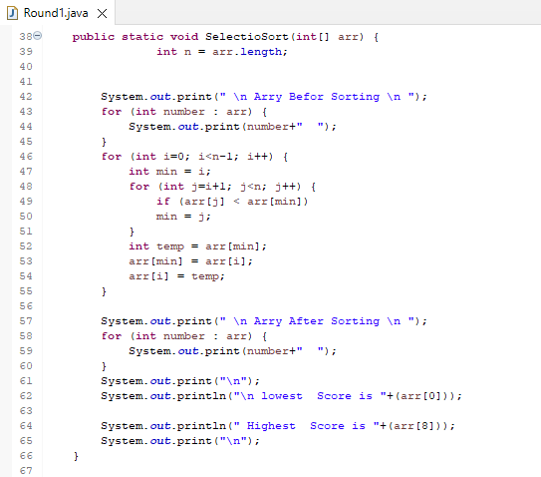

**Algorithm of Bubble Sort**

Bubble Sort is a straightforward sorting algorithm that works by repeatedly stepping through the list, comparing adjacent elements, and swapping them if they are in the wrong order. Here is a detailed breakdown of the Bubble Sort algorithm:[7]

**1. Start:**

Begin by comparing the first two elements of the list.

**2. Compare and Swap:**

If the first element is greater than the second element, swap them.

Move to the next pair of elements (the second and third elements), and repeat the comparison and swapping process.

**3. Iterate Through the List:**

Continue this process until you reach the end of the list. By this point, the largest element will have "bubbled up" to the end of the list.

**4. Repeat for Remaining Elements:**

Repeat steps 1–4 for the remaining elements, excluding the last element since it is already in its correct position.

**5. Decreasing Range:**

Repeat the entire process for a decreasing range of elements until the entire list is sorted.

In each iteration, the largest unsorted element settles in its correct position at the end of the list.

**Visualization:**

Initial List: [7, 2, 5, 1, 8]

Iteration 1: [2, 5, 1, 7, 8] (Comparisons and swaps)

Iteration 2: [2, 1, 5, 7, 8] (More comparisons and swaps)

Iteration 3: [1, 2, 5, 7, 8] (Largest element "bubbled up")

Iteration 4: [1, 2, 5, 7, 8] (Final iteration, excluding the sorted last element)

**Advantages:**

* Simple and easy to understand.
* Requires minimal auxiliary space as it performs in-place sorting.

**Limitations:**

* Inefficient for large datasets due to higher time complexity.
* Less practical compared to more advanced sorting algorithms for substantial datasets.

the Bubble Sort algorithm systematically compares and swaps adjacent elements until the entire list is sorted, making it a fundamental sorting technique despite its limitations in terms of efficiency for larger datasets.[7]

**Bubble Sort method**

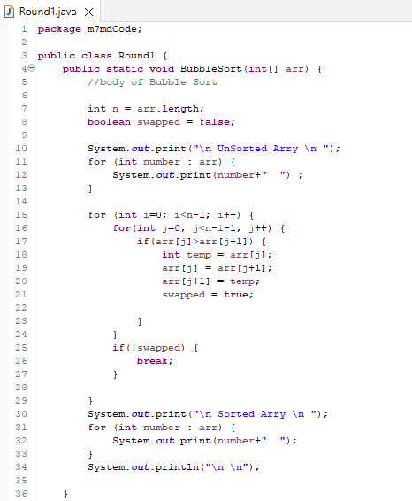

**Searching Algorithms**

Searching algorithms play a crucial role in locating specific elements within a dataset. Linear Search, a fundamental sequential search algorithm, operates by systematically traversing through each element of a list until it finds the desired element or exhausts the entire dataset. Here is a detailed description of the Linear Search algorithm:[8]

**1. Initialization:** Begin the search at one end of the list, typically the first element.

**2. Sequential Search:** Sequentially go through each element of the list one by one.

**3. Comparison:** Compare the current element with the target element you are searching for.

**4. Element Found:** If the current element matches the target element, the search is successful, and the position/index of the element is identified.

**5. Continue Search:** If the current element does not match the target element, continue the search by moving to the next element in the list.

**6. End of Dataset:** Repeat steps 3–5 until the desired element is found, or the end of the dataset is reached.

**7. Search Outcome:** If the desired element is found, the search concludes, and the position/index of the element is reported.

If the entire dataset is traversed without finding the element, the search is unsuccessful.

**Visualization:**

Target Element: 5

List: [3, 8, 2, 5, 1, 7]

Iteration 1: Compare 3 (No match, continue)

Iteration 2: Compare 8 (No match, continue)

Iteration 3: Compare 2 (No match, continue)

Iteration 4: Compare 5 (Match found, report index 3)

**Advantages:**

* Simple and easy to understand.
* Applicable to both sorted and unsorted lists.

**Limitations:**

* Inefficient for large datasets as it performs a sequential search.
* Time complexity is O(n), where n is the size of the dataset.

Linear Search is a straightforward but potentially less efficient searching algorithm that sequentially traverses through each element of a list until it finds the desired element or reaches the end of the dataset. It is a practical choice for small datasets or situations where simplicity is prioritized.[8]

**Linear Search method**

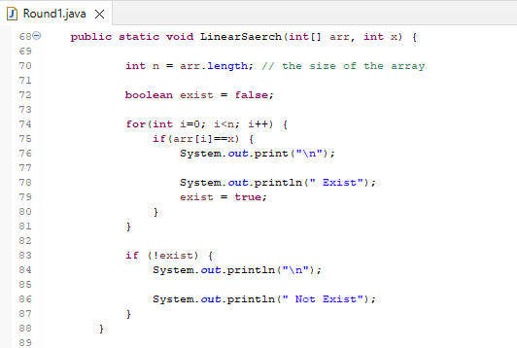

**Main mathod**

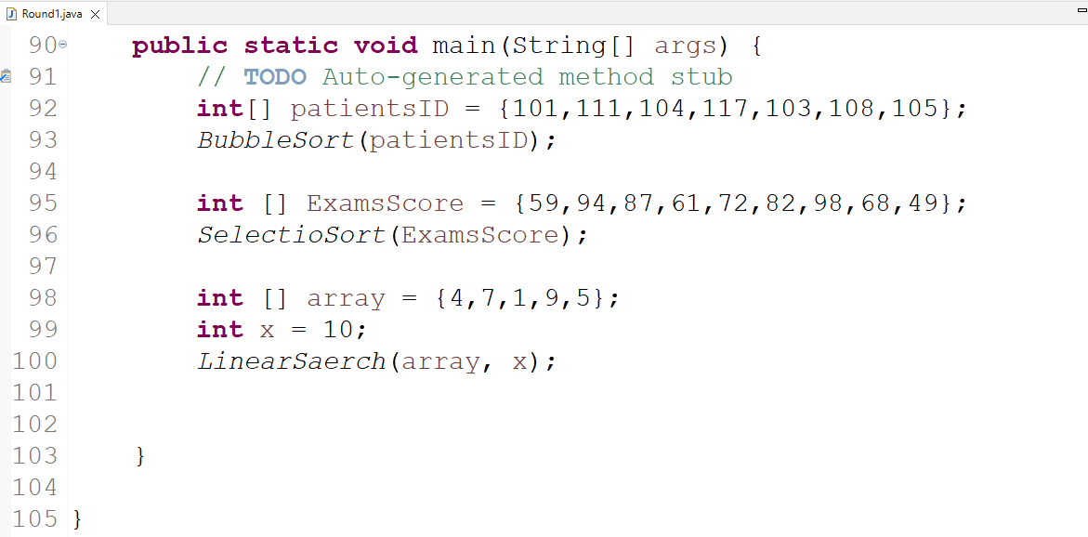

**Execution**

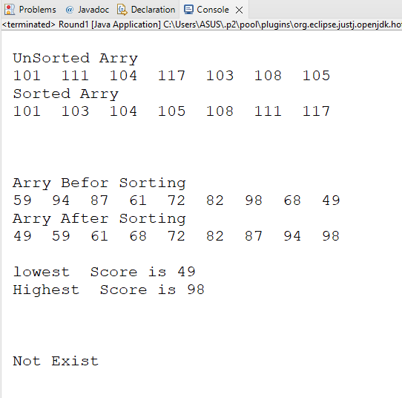

**How Computers Understand Programming**

Computers comprehend programming languages through a crucial intermediary process known as translation. This process involves the use of various tools, such as compilers, interpreters, assemblers, and linkers, to convert human-readable code into machine-executable instructions. Here's an overview of how this translation process enables computers to understand and execute programs:[9]

**1. Programming Languages:**

* Humans write programs in high-level programming languages such as Python, Java, C++, or others. These languages use syntax and structures that are more readable and understandable to humans.[9]

**2. Compiler:**

* A compiler is a specialized program that translates the entire source code written in a high-level language into machine code or an intermediate code. This translation is typically done all at once before the program is executed.[9]

**3. Interpreter:**

* An interpreter, on the other hand, translates the source code line by line during runtime. It reads a single line of code, converts it to machine code or an intermediate code, and executes it immediately. This process continues until the entire program is executed.[9]

**4. Assembler:**

* For low-level programming languages like Assembly language, an assembler is used. It translates assembly code into machine code, which consists of binary instructions that the computer's central processing unit (CPU) can directly execute.[9]

**5. Linker:**

* The linker is responsible for combining various object files produced during the compilation process into a single executable file. It resolves references between different parts of the code and ensures that the final program is coherent and ready for execution.[9]

**Visualization of the Process:**

High-Level Code (e.g., C++)

Compiler

Intermediate Code or Machine Code

Interpreter or Assembler

Executable Code

**Execution:**

* The generated executable code, whether directly in machine code or an intermediate code, contains instructions that the computer's hardware can execute.

**Key Points:**

**Abstraction:** High-level programming languages provide a level of abstraction, allowing programmers to focus on logic without being concerned about the specific machine details.[9]

**Translation:** Compilers and interpreters serve as translators, converting high-level code into a form understandable and executable by the computer.[9]

**Hardware Interaction:** The final output is machine code that the computer's hardware can directly interpret and execute.

the translation process bridges the gap between human-readable code and the machine-level instructions that computers can execute, making programming accessible and efficient for both programmers and computers.[9]

**Programming Paradigms**

Programming paradigms are fundamental styles or methodologies that dictate how programmers structure and organize their code. Let's delve into three prominent paradigms: Procedural Programming, Object-Oriented Programming (OOP), and Event-Driven Programming.[10]

**Procedural Programming**

Procedural programming, a derivative of imperative programming, revolves around the concept of the procedure call. Procedures, akin to routines or subroutines, are sequences of computational steps. These steps are executed one after another, providing a clear and linear flow to the program. Procedural programming emphasizes breaking down a problem into smaller, manageable procedures, promoting modularity and reusability of code.[10]

**Object-Oriented Programming (OOP)**

Object-Oriented Programming is a paradigm centered on the concept of objects. An object encapsulates both data and code. The data is represented as fields, attributes, or properties, while the code is implemented as procedures or methods. OOP promotes the organization of code around real-world entities, fostering encapsulation, inheritance, and polymorphism. This paradigm enhances code maintainability, scalability, and fosters a more intuitive representation of complex systems.[10]

**Event-Driven Programming:**

Event-driven programming takes the lead in graphical user interfaces and network servers. In an event-driven application, an event loop actively listens for events, such as user inputs or system signals. When an event occurs, it triggers a callback function, responding dynamically to the event. This paradigm allows for asynchronous and responsive behavior, making it well-suited for applications that require real-time interaction. Event-driven programming excels in creating interactive and user-friendly interfaces.[10]

**Comparing the Paradigms:**

* **Procedural Programming**: Ideal for tasks with a clear sequence of steps. Best suited for simple, linear processes.
* **Object-Oriented Programming:** Well-adapted for modeling complex systems, promoting code reuse, and enhancing modularity.
* **Event-Driven Programming:** Excelling in scenarios where dynamic responses to user inputs or system events are crucial, making it a go-to choice for interactive applications.[10]

Each programming paradigm serves a unique purpose, and the choice often depends on the nature of the task. Procedural programming provides simplicity and straightforwardness, OOP excels in managing complexity, and event-driven programming brings dynamism to user interactions. The versatility to choose the right paradigm empowers programmers to tailor their approach based on the requirements of the project, ensuring efficient and effective code development.[10]

**Relationship Between Procedural, Object-Oriented, and Event-Driven Programming**

The realms of procedural programming, object-oriented programming (OOP), and event-driven programming (EDP) are interconnected, each influencing and evolving in relation to the others.[11]

**Relationship between Procedural and Object-Oriented Programming:**

Procedural programming is a paradigm focused on functions, whereas Object-Oriented Programming (OOP) is a more advanced iteration, designed to address the limitations of procedural programming. In procedural programming, functions are the key building blocks, tackling various aspects of a problem. OOP takes a leap forward by dividing the program into multiple objects. Objects encapsulate both data and code, providing a more modular and reusable structure.

The relationship lies in the evolutionary path from procedural to object-oriented. OOP emerges as a refinement, introducing concepts like encapsulation, inheritance, and polymorphism to manage complexity more effectively.[11]

**Relationship between Event-Driven and Object-Oriented Programming:**

Event-Driven Programming (EDP) and Object-Oriented Programming can coexist harmoniously due to their orthogonal nature. They share core principles like encapsulation, polymorphism, and inheritance.

In the marriage of OOP and EDP, objects gain the ability to publish events, notify other objects of events, and subscribe to event notifications from fellow objects. Many event-driven languages are inherently object-oriented, with objects waiting for events to occur. This combination enhances the responsiveness and interactivity of applications.

Moreover, the relationship extends to the fact that OOP, EDP, and procedural programming are intertwined. Object-oriented programming inherits from procedural programming, with both utilizing functions. Even event-driven programming borrows certain concepts from both procedural and object-oriented paradigms. The usage of loops, data types, and structures is a common thread that ties them together.

the relationship between procedural, object-oriented, and event-driven programming is one of evolution and integration. OOP refines the procedural approach, and EDP complements OOP by adding a dynamic, event-triggered dimension. The interrelated nature of these paradigms allows programmers to leverage their strengths based on the specific requirements of a project, providing a versatile toolkit for effective and efficient code development.[11]

**Software Development Life Cycle (SDLC): Guiding the Software Building Process**

**What is SDLC?**

SDLC, or Software Development Life Cycle, is a systematic process followed by software organizations for building software. It entails a well-defined plan that outlines how to develop, maintain, replace, and enhance specific software.[12]

**Stages of the Software Development Life Cycle Model:**

The SDLC consists of distinct phases, each contributing to the overall software development process:[12]

**1. Planning**

**2. Designing**

**3. Implementing**

**4. Testing**

**5. Deployment**

**SDLC Phases or Stages:**

**1. Planning:**

The planning phase in the SDLC serves as the project's compass, guiding the entire software development journey. It begins with the initiation of the project, involving activities such as conducting feasibility studies to assess its viability, defining project objectives, and forming a dedicated project team. Comprehensive documentation, including project plans, resource allocations, and risk assessments, is meticulously crafted during this phase. The planning stage is crucial for aligning the project with organizational goals, setting clear expectations, and establishing the groundwork for subsequent stages.[12]

**2. Design:**

The design phase is where the conceptualization of the software takes shape. It involves translating the requirements gathered in the planning stage into a blueprint for the software's architecture and functionality. This phase includes high-level architectural design, defining system specifications, and creating detailed technical designs. Designers focus on creating a scalable, maintainable, and efficient structure for the software. The outcome is a comprehensive design document that serves as a roadmap for the implementation phase, ensuring a cohesive and well-thought-out foundation for the software.[12]

**3. Implementation:**

With the design in hand, the implementation phase kicks off the actual coding and development of the software. Developers start writing code based on the specifications outlined in the design document. This phase is characterized by collaborative coding efforts, adherence to coding standards, and continuous integration. Frequent code reviews and testing during the implementation phase help identify and rectify issues early in the development process. The result is a functional software product that aligns closely with the client's requirements and the design specifications.[12]

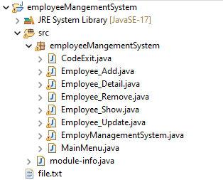

This is my employee Management System classes in java; I’ll explain each of them.

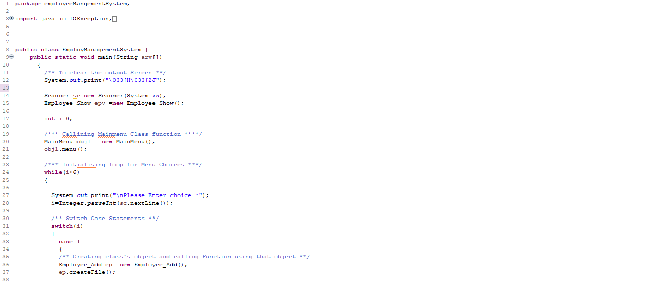

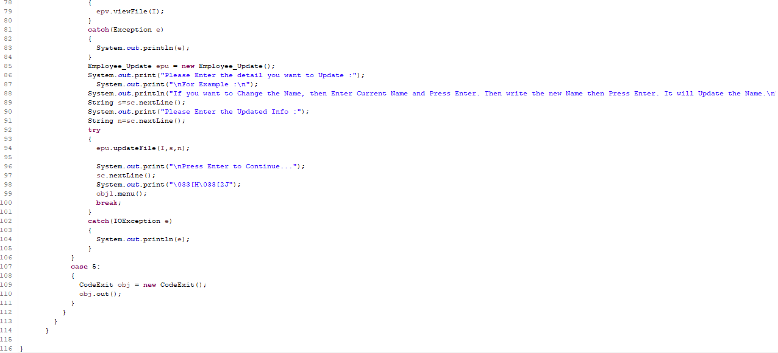

**1. EmployeeManagementSystem Class:**

The **EmployeeManagementSystem** class serves as the core orchestrator of the entire system. It encapsulates the overall functionality and manages the interactions between various components. This class is responsible for initializing the system, handling user inputs, and coordinating the execution of different modules, such as adding, updating, showing, or removing employee details. It acts as the entry point for the application, ensuring seamless communication between the user and the system.

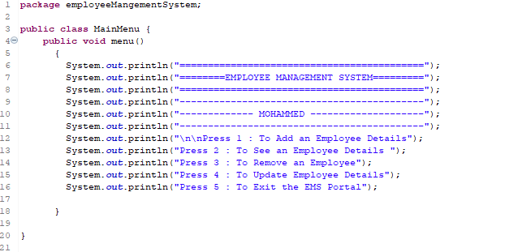

**2. MainMenu Class:**

The **MainMenu** class is designed to provide the user with a clear and interactive interface for navigating through different functionalities offered by the Employee Management System. It displays a menu of options, such as adding, updating, showing, or removing employee records. The primary role of this class is to accept user inputs, validate them, and direct the flow of execution to the corresponding modules based on the selected option. It ensures a user-friendly experience and facilitates smooth navigation within the system.

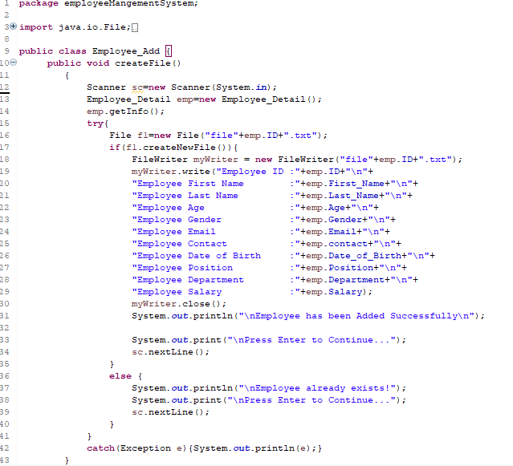

**3. Add_Employee Class:**

The **Add_Employee** class focuses on the functionality related to adding new employee records to the system. It contains methods and attributes that capture and validate employee details, such as name, ID, position, and salary. This class is responsible for interacting with the user to gather necessary information, validating the input data, and updating the system's data structures or storage with the new employee details.

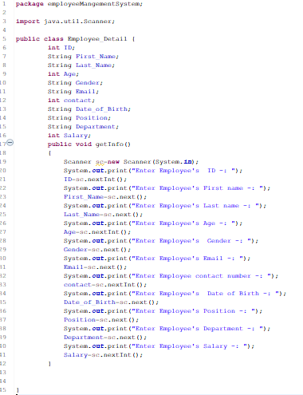

**4. Employee_Detail Class:**

The **Employee_Detail** class is designed to encapsulate the structure and attributes of an individual employee. It serves as a blueprint for creating instances of employee objects, each representing a unique employee in the system. This class typically includes attributes like name, ID, position, and salary, along with methods for accessing and modifying these attributes.

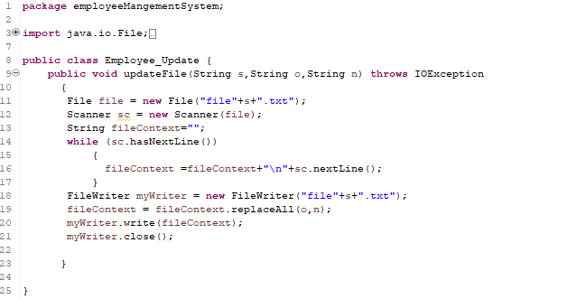

**5. Update_Employee Class:**

The **Update_Employee** class is responsible for handling the functionality related to modifying existing employee records. It interacts with the user to identify the employee to be updated and prompts for the new details. This class ensures that the modifications are appropriately validated and reflected in the system's data structures, maintaining data integrity.

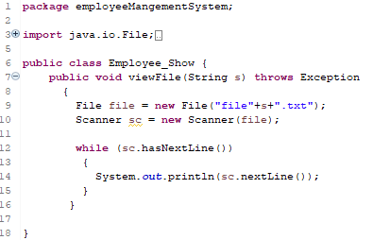

**6. Show_Employee Class:**

The **Show_Employee** class is focused on presenting employee details to the user. It may include methods for displaying a list of all employees or specific details based on user queries. This class contributes to the user's understanding of the existing workforce within the organization and aids in decision-making.

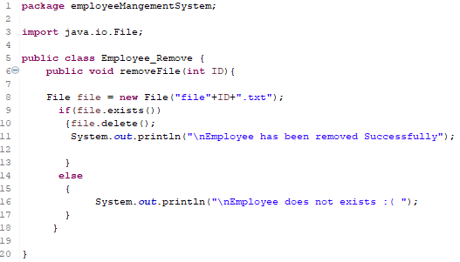

**7. Remove_Employee Class:**

The **Remove_Employee** class handles the functionality related to deleting employee records from the system. It prompts the user to specify the employee to be removed, validates the input, and ensures the proper removal of the selected employee from the system's data structures.

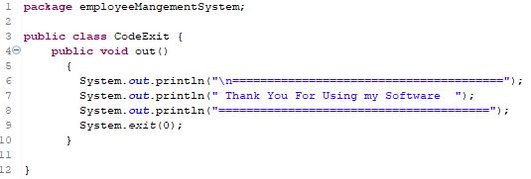

**8. CodeExit Class:**

The **CodeExit** class manages the termination of the Employee Management System. It provides an organized and graceful exit mechanism, ensuring that all necessary cleanup activities are performed before the application concludes. This class handles user requests to exit the system and implements proper shutdown procedures.

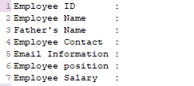

**9. file.txt:**

The **file.txt** represents the external file where the system stores and retrieves employee data persistently. This file serves as a data repository, allowing the system to maintain records even after shutting down and restarting. The Employee Management System interacts with **file.txt** through file I/O operations to read and write employee data, ensuring data persistence and integrity.

Each class within the Employee Management System has a well-defined role, contributing to the overall functionality and efficiency of the system. The collaborative efforts of these classes ensure that the system effectively manages employee information, provides a user-friendly interface, and maintains data integrity.

**4. Testing:**

Testing is a critical phase focused on verifying the functionality, performance, and security of the developed software. It encompasses various testing methodologies, including unit testing, integration testing, system testing, and user acceptance testing. Quality assurance teams rigorously evaluate the software against predefined criteria to ensure it meets the specified requirements. Test cases are executed, and any identified bugs or issues are addressed by the development team. Testing ensures the software's reliability, robustness, and adherence to quality standards before moving to the next phase.[12]

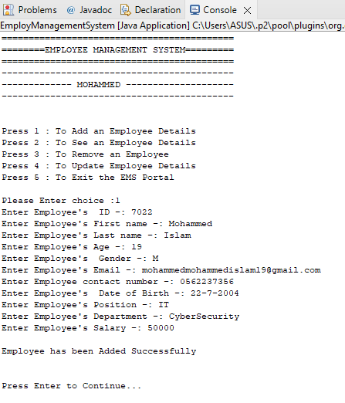

This is a screenshot of an Employee Management System (EMS) application interface, displayed in a console window. It shows the process of adding an employee’s details into the system. The EMS is a tool that helps improve employee satisfaction and productivity to help a company achieve their overall goals. These tools help monitor, assess and control employees’ working hours and efficiently utilize human resources. The EMS eliminates the requirement of using several tools and helps improve the HR team’s efficiency, as they no longer switch between different tools to track the employee’s performance and maintain their records. Using a dedicated EMS can help an HR manager streamline the hiring process and improve workplace efficiency

In the image, a series of prompts and responses are visible where user input is being provided to add an employee named Mohammed Islam with ID 7022 to the system. Details such as name, ID number, gender, email address, contact number, date of birth, position, department and salary are entered into specific fields prompted by the system. The final line indicates that “Employee has been Added Successfully”.

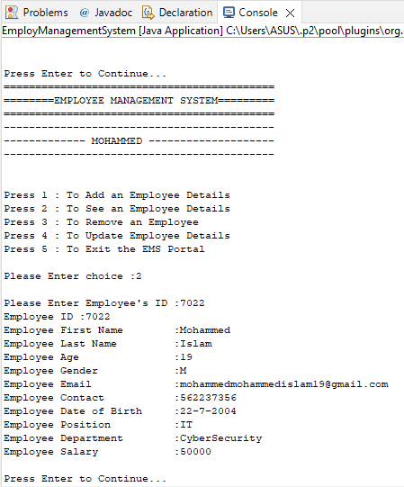

In the image, a series of prompts and responses are visible where user input is being provided to add an employee named Mohammed Islam with ID 7022 to the system. Details such as name, ID number, gender, email address, contact number, date of birth, position, department and salary are entered into specific fields prompted by the system. The final line indicates that “Employee has been Added Successfully”.

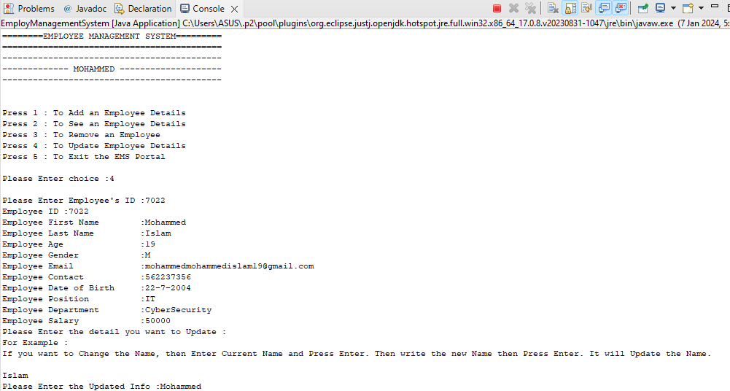

In the image, the user has selected option 4 to update employee details. Employee ID 7002’s information is displayed: first name Mohammed, last name Islam, age 19 etc. The user is prompted to enter the detail they want to update and provides an example of how to change the name. The last line shows that the user has updated the first name from “Islam” to “Mohammed”.

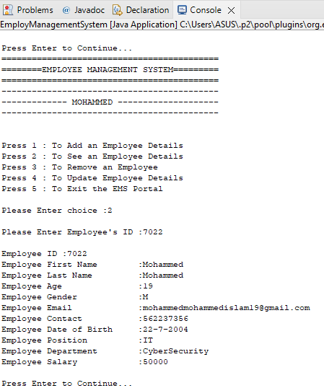The image shows the following options for managing employee details:

Press 1 : To Add an Employee Details

Press 2 : To See an Employee Details

Press 3 : To Remove an Employee

Press 4 : To Update Employee Details

Press 5 : To Exit the EMS Portal

The user has selected option 2 to see an employee’s details. The employee information is displayed below including ID, name, gender, email contact, date of birth, position, department and salary. The gender field contains initials which might be considered sensitive or personal information.

Please Enter choice :2

Please Enter Employee's ID :7022

Employee ID :7022

Employee First Name :Mohammed

Employee Last Name :Mohammed

Employee Gender :M

Employee Age :

Employee Email :

Employee Contact :

Employee Date of Birth :

Employee Position :

Employee Department :

Employee Salary :

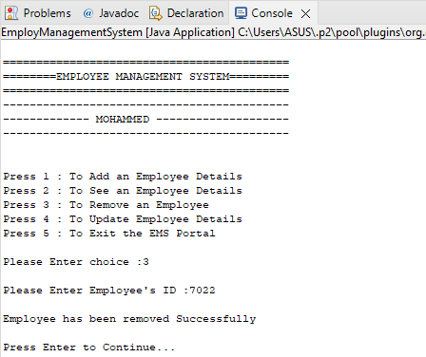

The image shows the following options for managing employee details:

Press 1 : To Add an Employee Details

Press 2 : To See an Employee Details

Press 3 : To Remove an Employee

Press 4 : To Update Employee Details

Press 5 : To Exit the EMS Portal

The user has selected option 3 to remove an employee with ID 7022. A message confirms that the employee has been removed successfully:

Please Enter choice: 3

Please Enter Employee's ID: 7022

Employee has been removed Successfully

Press Enter to Continue...

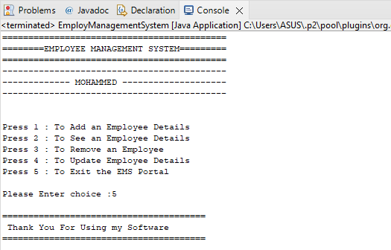

The image shows the following options for managing employee details:

Press 1 : To Add an Employee Details

Press 2 : To See an Employee Details

Press 3 : To Remove an Employee

Press 4 : To Update Employee Details

Press 5 : To Exit the EMS Portal

The user has selected option 5 to exit the EMS portal. A message at the bottom thanks the user for using the software:

Please Enter choice :5

Thank You For Using My Software

**5. Deployment:**

The deployment phase marks the transition of the software from the development environment to the production environment, making it accessible to end-users. Deployment involves activities such as installing the software, configuring it for the intended environment, and validating its functionality in the real-world setting. A well-executed deployment ensures a seamless rollout of the software, minimizing disruptions and ensuring a positive user experience. Continuous monitoring and support are essential during the initial deployment to address any unforeseen issues promptly.

The Software Development Life Cycle is a holistic approach that encompasses careful planning, thoughtful design, meticulous implementation, rigorous testing, and smooth deployment. Each stage contributes uniquely to the overall success of the software development project, ensuring that the end product meets client expectations, quality standards, and organizational objectives.[12]

**SDLC Models:**

**1. Waterfall Model**

**2. Agile Model**

**3. Iterative Model**

**4. Spiral Model**

**5. V-Shaped Model**

**6. Big Bang Model**

**Waterfall Model:**

A linear, sequential approach to SDLC where each phase must be completed before moving on to the next.[12]

**Agile Model:**

An iterative development approach with smaller iterations, emphasizing adaptability and collaboration.[12]

**V-Shaped Model:**

A model that associates testing with each development stage, resembling a V-shape.[12]

**Which Methodology is Right for You?**

The choice of methodology depends on factors like project complexity, requirements volatility, and team dynamics. Agile is often preferred for dynamic projects, while Waterfall is suitable for well-defined, stable projects.[12]

**What is the Need for SDLC:**

**Disciplined Approach:** SDLC models provide a disciplined and systematic method for software design.[12]

**Problem Solving:** Breaking down the software design process into small parts makes it more understandable and manageable.[12]

**Detailed Planning:** SDLC comprises a step-by-step plan for designing, developing, testing, and maintaining software.

SDLC serves as a roadmap for software development, ensuring a structured and organized approach from project initiation to deployment and maintenance. It enhances collaboration, problem-solving, and overall project success.[12]

**Integrated Development Environment (IDE): Streamlining Software Development**

**What is an IDE:**

An Integrated Development Environment (IDE) is a comprehensive software application designed to assist programmers in efficiently developing software code. It consolidates various common activities involved in writing software, including editing source code, building executables, and debugging. Essentially, an IDE is an environment or a combination of tools, such as a text editor, debugger, and compiler.[13]

**Why is an IDE Important?**

The primary objectives of an IDE are:

**Ease of Software Development:** Facilitating a smoother software development process.

**Error Detection:** Detecting and minimizing code errors and typos.

**Basic Features of an IDE:**

**Text Editor:** Every IDE includes a text editor designed for writing and updating source code.[13]

**Debugger:** Enables users to identify and fix issues before compiling. Debugging tools simulate real-world scenarios to test functionality and performance.[13]

**Compiler:** Converts written code into machine language.[13]

**Programming Language Support:** IDEs typically support a specific programming language, though some may support multiple languages.[13]

**Integrations and Plugins:** As an integrated development environment, IDEs often integrate with other development tools. Proper integrations improve development workflows and productivity.[13]

**Life without Eclipse IDE:**

In the absence of an IDE like Eclipse, developers may face challenges such as:

**Error Identification:** Lack of color-coded error indications, making it harder to identify and rectify issues.[13]

**Correction Features:** Absence of features that assist in quickly correcting errors, slowing down the development process.[13]

**Organization Issues:** Without colors and suggestions, maintaining organization within the program becomes challenging.[13]

**Some Advanced Text Editors IDE:**

**1. Visual Studio Code:** A lightweight, powerful code editor with rich features and extensions.[13]

**2. Atom:** A hackable text editor with a built-in package manager and a vibrant community.[13]

**3. Sublime Text:** A sophisticated text editor known for its speed, ease of use, and extensive plugin support.

These advanced text editors offer features comparable to traditional IDEs and are popular choices for developers seeking flexibility and a streamlined coding experience.[13]

**Debugging**

**What is the Debugging Process:**

Debugging is the systematic process of identifying and resolving errors or bugs in a software system. This crucial aspect of software engineering addresses issues that may cause malfunctions, poor performance, or incorrect results. Debugging is essential as it helps developers uncover problems that are challenging to detect during code reviews or may only surface in specific situations.[14]

**Launching and Debugging a Java Program:**

Debugging a Java program is a straightforward process:

1. Right-click on the Java editor class file in the Package Explorer.

2. Select "Debug As → Java Application" or use the shortcut Alt + Shift + D, J.[14]

**Breakpoints:**

A breakpoint is a signal that instructs the debugger to temporarily pause the execution of a program at a specified point in the code.[14]

**How to Create Breakpoints:**

To set a breakpoint in your source code:

* Right-click in the left margin of the Java editor.
* Select "Toggle Breakpoint" or double-click on the desired spot.[14]

**Conditional Breakpoints:**

In addition to regular breakpoints, developers can set conditional breakpoints. These breakpoints pause execution only when a specified condition is met, aiding in pinpointing and resolving bugs.[14]

**Debugging Perspective:**

The debugging perspective provides additional views to analyze a program during debugging. Key views include:[14]

* Debug view
* Breakpoints view
* Variables/Expression view
* Display view
* Console view

When a Java application is run in debug mode, users are prompted to switch to the debug perspective.[14]

**Stepping Commands:**

Stepping commands are used during debugging to navigate through code execution step by step. Common stepping commands include Step Into, Step Over, and Step Return.[14]

**Trigger Point:**

A trigger point is a location in the code where an issue or bug is present. Similar to a pain point in the body, it serves as the source of a problem that requires attention.[14]

**Remotely Debugging:**

Remote debugging allows developers to debug code running on a remote server or device. This is particularly useful for testing and debugging on the actual devices or servers where the software will run, facilitating a more accurate and efficient debugging process.[14]

**Coding Standards and Best Practices**

Coding standards serve as a compass in the realm of software development, providing guidelines and best practices to ensure the creation of consistent, high-quality code. These standards encompass rules, techniques, and practices that contribute to the development of cleaner, more readable, and efficient code with minimal errors. Here's an overview of the importance and impact of coding standards:[15]

**Definition:** Coding standards are a set of guidelines that prescribe a common structure and style for writing code. They act as a shared set of rules within a development team to promote uniformity and coherence in the codebase.[15]

**Ensuring Consistency:** Coding standards enforce a consistent format and structure across the codebase. This consistency enhances collaboration and makes it easier for multiple developers to work on the same project, fostering a sense of coherence.[15]

**Improving Readability:** By adhering to coding standards, developers contribute to the creation of readable and comprehensible code. Consistent naming conventions, indentation, and formatting make it easier for developers to understand, maintain, and debug code.[15]

**Enhancing Collaboration:** When everyone on a development team follows the same set of coding standards, collaboration becomes more seamless. Developers can easily review and understand each other's code, leading to increased productivity and reduced chances of introducing errors[15]

**Reducing Error Rates:** Coding standards incorporate best practices that help minimize the likelihood of introducing errors. They include guidelines on error handling, code organization, and defensive programming, contributing to the creation of robust and reliable software.[15]

**Facilitating Maintenance:** Well-documented coding standards make maintenance tasks more straightforward. When a developer needs to update or modify existing code, adherence to coding standards ensures that the changes are applied consistently across the codebase.[15]

**Enabling Scalability:** As a project grows, adherence to coding standards becomes crucial for scalability. Consistent code structure and organization make it easier to scale a project by adding new features, modules, or collaborating with a larger development team.[15]

**Key Components of Coding Standards:**

**Naming Conventions:** Guidelines for naming variables, functions, classes, and other code elements.[15]

**Indentation and Formatting:** Consistent rules for code indentation, formatting, and line length.[15]

**Documentation:** Standards for code comments, inline documentation, and readme files.[15]

**Error Handling:** Best practices for handling errors and exceptions.[15]

**Code Organization:** Guidelines for organizing code files, directories, and project structure.[15]

**Testing Practices:** Recommendations for writing and maintaining unit tests.[15]

**Adopting Coding Standards:**

**Team Consensus:** Establish coding standards collaboratively within the development team, ensuring consensus and buy-in from all members.[15]

**Regular Review and Updates:** Coding standards should be regularly reviewed and updated to reflect changes in technology, team preferences, or project requirements.[15]

**Automation Tools:** Use automated tools to enforce coding standards during development, ensuring adherence and catching violations early in the development process.[15]

coding standards play a vital role in fostering code consistency, readability, and quality. They are an essential component of a disciplined and collaborative software development process, contributing to the creation of maintainable, scalable, and error-resistant code.[15]

[1] “What is an algorithm? | TechTarget,” WhatIs. Accessed: Jan. 13, 2024. [Online]. Available: https://www.techtarget.com/whatis/definition/algorithm

[2] “Characteristics of an Algorithm - Coding Ninjas.” Accessed: Jan. 13, 2024. [Online]. Available: https://www.codingninjas.com/studio/library/characteristics-of-an-algorithm

[3] “Know the Difference Between Algorithm and Program - Shiksha Online.” Accessed: Jan. 13, 2024. [Online]. Available: https://www.shiksha.com/online-courses/articles/difference-between-algorithm-and-program/

[4] “Flowchart Symbols.” Accessed: Jan. 13, 2024. [Online]. Available: https://www.smartdraw.com/flowchart/flowchart-symbols.htm

[5] “Types of Algorithms.” Accessed: Jan. 13, 2024. [Online]. Available: https://www.linkedin.com/pulse/types-algorithms-emran-khandaker-evan

[6] “Selection Sort Algorithm in C - Shiksha Online.” Accessed: Jan. 13, 2024. [Online]. Available: https://www.shiksha.com/online-courses/articles/selection-sort/

[7] “Bubble Sort - Data Structure and Algorithm Tutorials,” GeeksforGeeks. Accessed: Jan. 13, 2024. [Online]. Available: https://www.geeksforgeeks.org/bubble-sort/

[8] “Search Algorithms – Linear Search and Binary Search Code Implementation and Complexity Analysis,” freeCodeCamp.org. Accessed: Jan. 13, 2024. [Online]. Available: https://www.freecodecamp.org/news/search-algorithms-linear-and-binary-search-explained/

[9] “Language Processors: Assembler, Compiler and Interpreter,” GeeksforGeeks. Accessed: Jan. 13, 2024. [Online]. Available: https://www.geeksforgeeks.org/language-processors-assembler-compiler-and-interpreter/

[10] “Object-Oriented, Event-Driven and Procedural Programming - 1263 Words | Report Example,” IvyPanda. Accessed: Jan. 13, 2024. [Online]. Available: https://ivypanda.com/essays/object-oriented-event-driven-and-procedural-programming/

[11] C. Schaller, “Answer to ‘what are the relationships among procedural, object oriented and event driven paradigms?,’” Stack Overflow. Accessed: Jan. 13, 2024. [Online]. Available: https://stackoverflow.com/a/74427215

[12] T. P. Manager and H. Clark, “The Software Development Life Cycle (SDLC): 7 Phases and 5 Models,” The Product Manager. Accessed: Jan. 13, 2024. [Online]. Available: https://theproductmanager.com/topics/software-development-life-cycle/

[13] “What is an IDE? - Integrated Development Environment Explained - AWS,” Amazon Web Services, Inc. Accessed: Jan. 13, 2024. [Online]. Available: https://aws.amazon.com/what-is/ide/

[14] C. Guindon, “Debugging the Eclipse IDE for Java Developers | The Eclipse Foundation.” Accessed: Jan. 13, 2024. [Online]. Available: https://www.eclipse.org/community/eclipse_newsletter/2017/june/article1.php

[15] “Coding Standards and Guidelines: A Comprehensive Guide With Examples And Best Practices.” Accessed: Jan. 13, 2024. [Online]. Available: https://www.lambdatest.com/learning-hub/coding-standards